|  |
| --- |
| [Company name] |
| Visualizing |
| [Document subtitle] |

|  |
| --- |
| Steven Renders  [Date] |

Table of Contents

Step 03 Visualizing 2

Add a Title 2

Add Slicers 2

Add a Chart 6

Add a Table 9

Add a TreeMap 11

Add Cards: 13

Add a Donut Chart 15

Rearrange report items 17

Create Phone Layout 17

Save Power BI Desktop file 18

# Step 03 Visualizing

You can continue to work on your previous Power BI Desktop file, or you can start with this file: Step 02 Step 03 Visualizing - START.pbix

Now that we have a Power BI Desktop file with a good data model, you are ready to create some reports and bring the information to life.

## Add a Title

Start by adding a title for the dashboard.

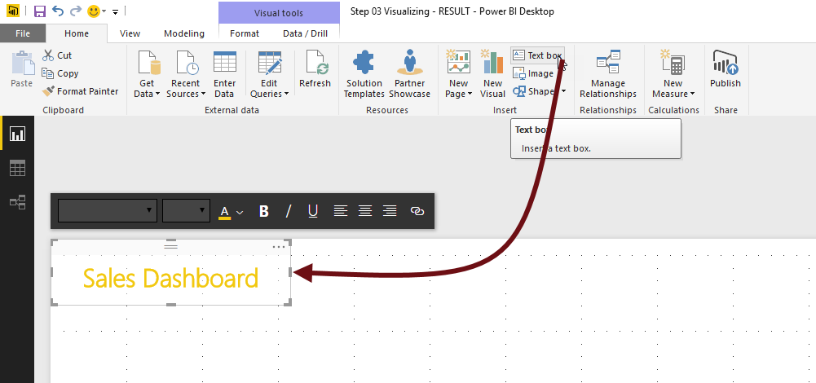

From the ribbon, select a textbox and use the formatting buttons to format the text. You can also include a logo if you want:



## Add Slicers

To filter the result, you can add some Slicers to the report. In the Visualizations, select Slicer, and drag in onto the report:

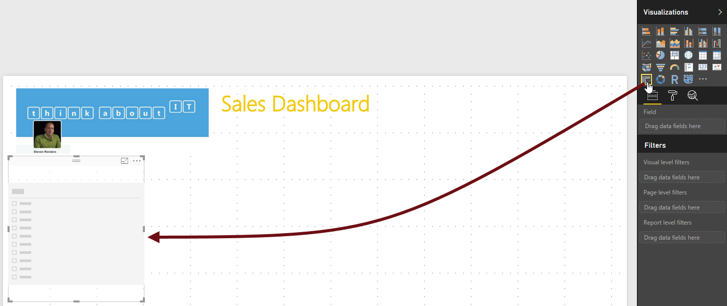

Then add the Customer Name to the Slicer:

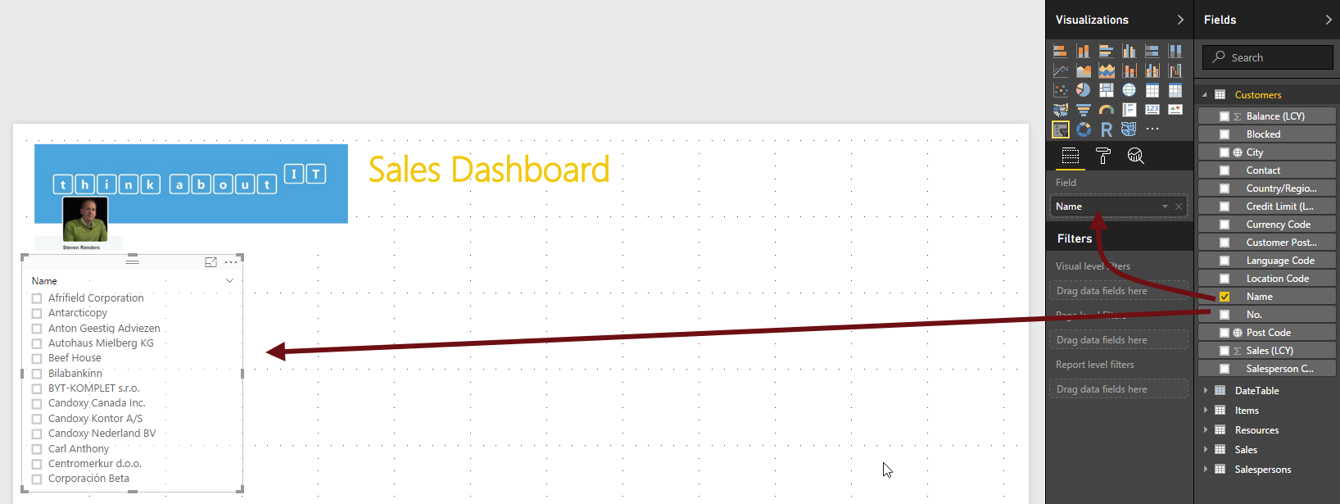

Next, enable Select All, using the Paint Brush:

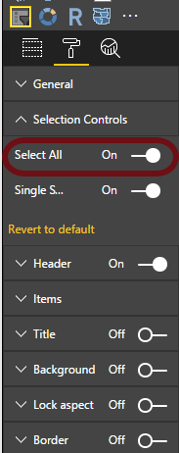

Now we’ll add another Slicer, for the Year:

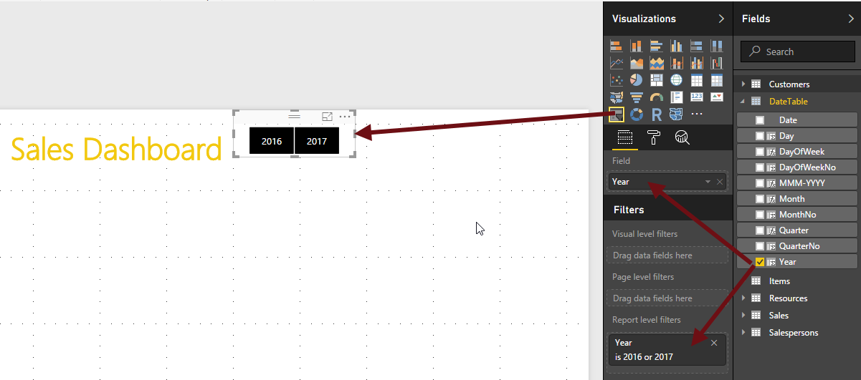

In the report level filters, filter on 2016 and 2017. Then, using the brush options:

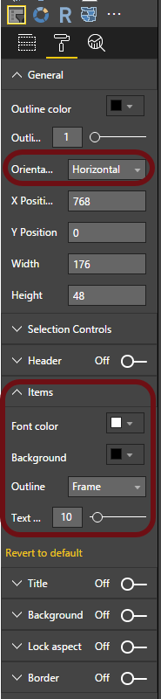

Change the orientation to horizontal, and set the colors for the Items, until the years resemble black squares, as in the above image.

Now repeat the same steps to add a Quarter slicer:

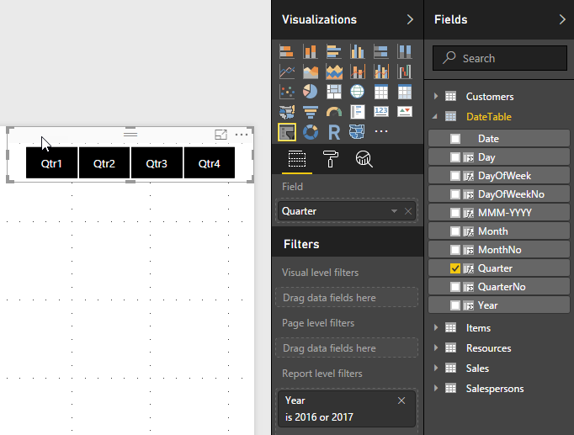

## Add a Chart

Next add an Area Chart to the report:

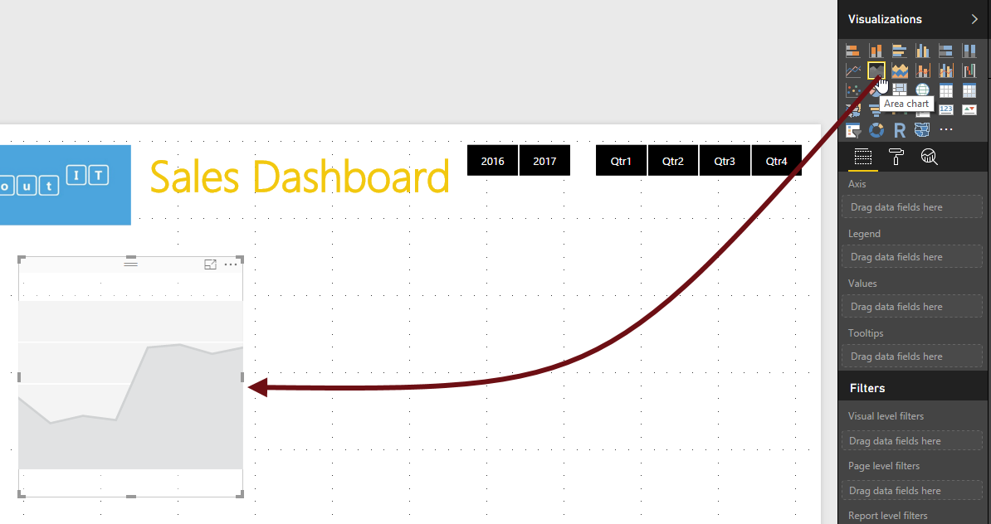

In the area chart set the following properties:

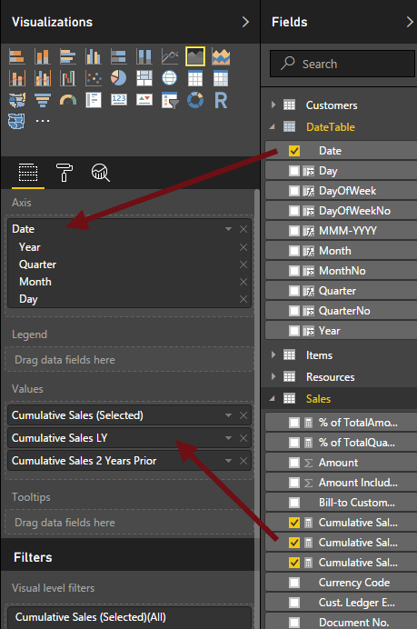

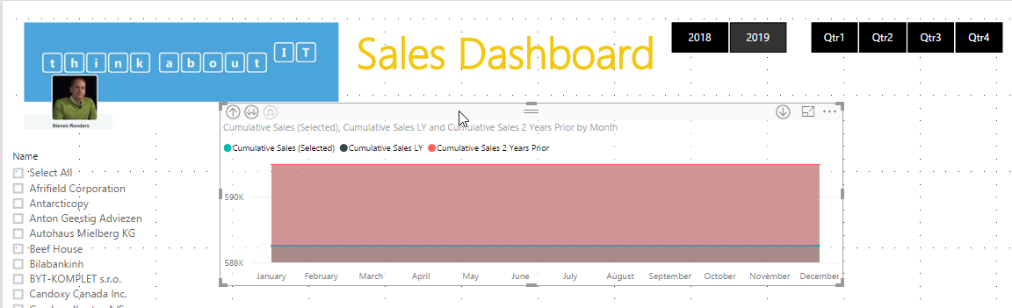

## Add a Table

Next add a Table to the report, below the chart:

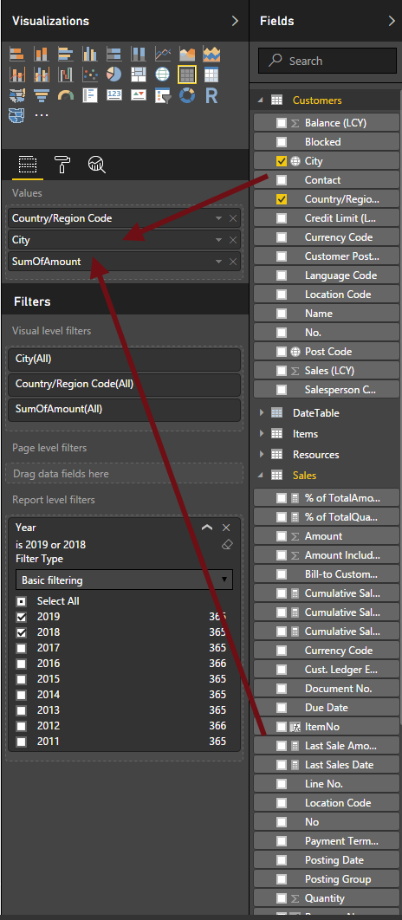

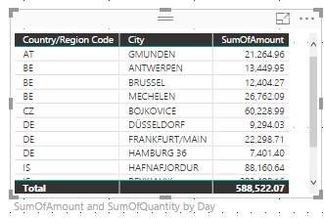

Then set the table style to condensed:

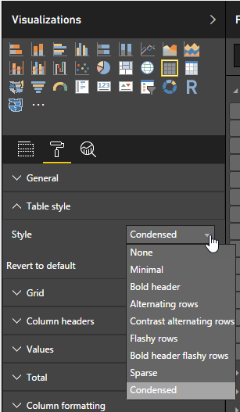

## Add a TreeMap

Now add a TreeMap to the report:

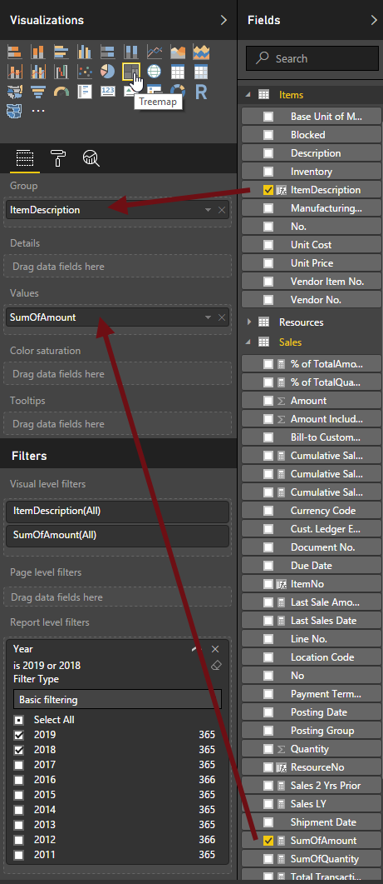

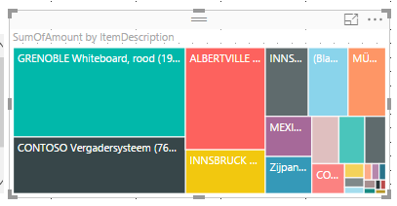

## Add Cards:

Now add a Card to the report:

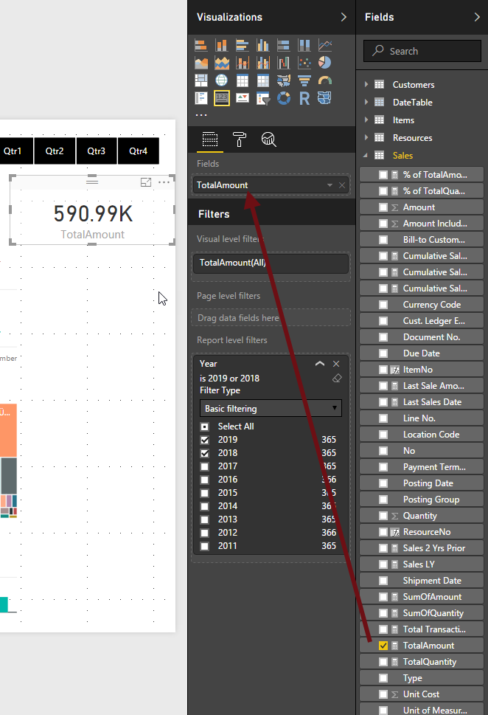

Repeat this for other KPI’s:

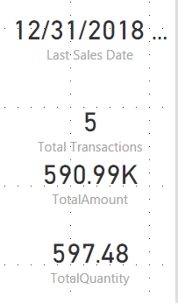

## Add a Donut Chart

Now add a Donut Chart to the report, for the total transactions per Salesperson:

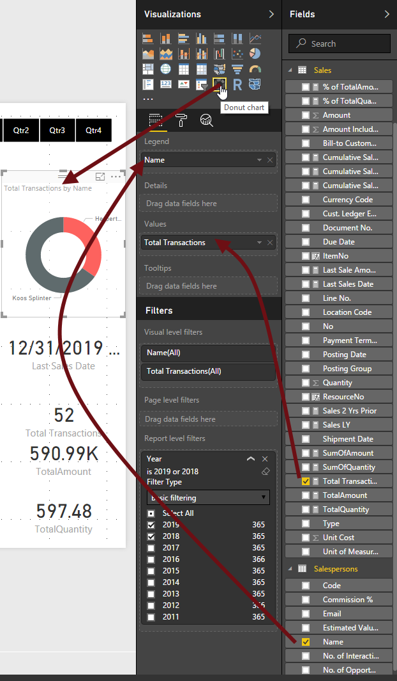

## Rearrange report items

In the View tab in the ribbon, select Show Gridlines and Snap Objects to Grid:

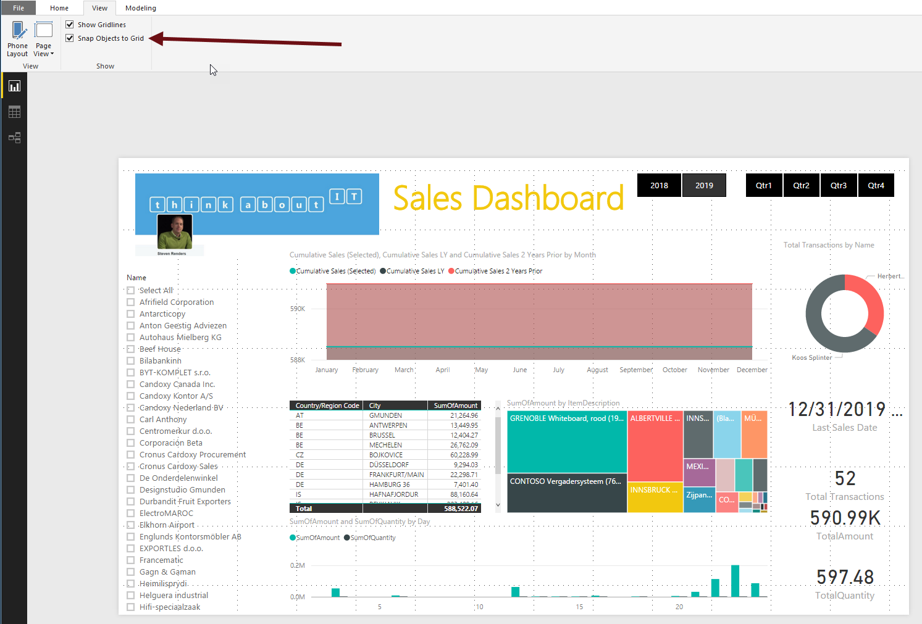

## Create Phone Layout

Select the Phone Layout in the ribbon. Then drag and drop report items to the layout:

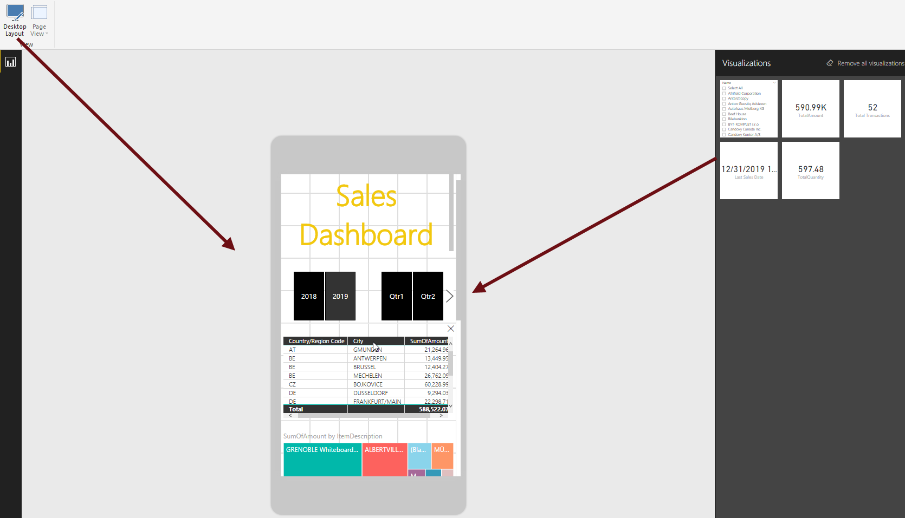

## Save Power BI Desktop file

Save your .pbix file.

